Web Development and Design POE

Part 1: Project Initiation and Planning

Name: Lethabo Surname: Moganedi
Student Number: ST 10526921 Module: Web Development Module Code: WEDE5021
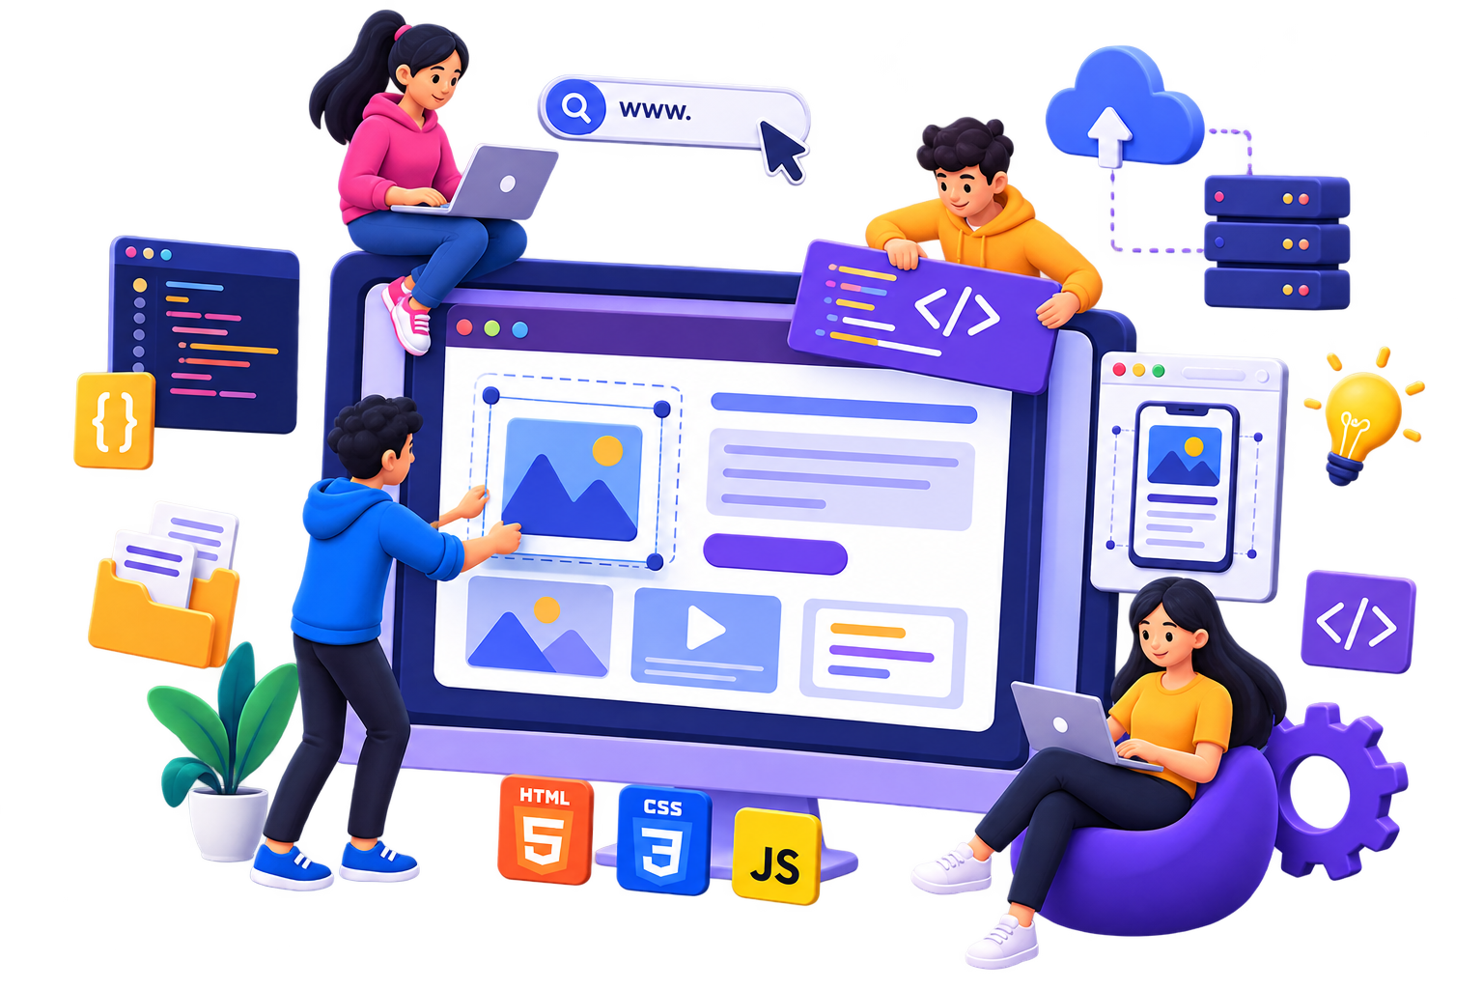
Lecturer: Mr. L. Matshakatini Submission Date: 14 August 2026

Table of Content

Paw Us SA Organization History Mission and Vision Statement Website Target Audience
- Website Goals and Objectives
- Current website Analysis
- Website features and functionality
- Design and User Experience Website Overall Design Approach

- Technical Requirements
- Timeline and Milestones
8. Budget References



Paw R Us SA Organization History
Paw R Us SA is a pet welfare organization that was founded in 2018 by a group of pet owners. This organization is an animal-focused organization that operates its activities online through a Facebook account.
Through their engagement with the public, they were able to establish a social-media presence that attracts pet lovers and donors for the organization.
The organization consistently shares its information about animals, raises awareness, and actively communicates with the public.
Over the years, the organization has been able to continue its services for homeless animals through the various help from donations and volunteers around the community.
The organization’s achievements and successful adoptions from the past years can all be seen through their Facebook account.

Mission and Vision Statement
Mission Statement:
- Paw R Us SA’s mission is to promote the welfare, protection, and safety of animals by providing homeless animals shelter, support, and the opportunity to get adopted.

Vision Statement:
- The organization’s vision is to create a safe environment where animals are treated with love and proper care that does not harm or threaten their safety.
- Through this vision, the organization wants to allow animals to live in a safe and loving environment that cares about animals.

Website Target Audience

Target Audience:
The target audience for the website designed for the NGO “Paw R Us SA,” is the following groups listed below:
- People are looking to adopt pets.
- Volunteers
- Potential donors and sponsors
- Pet owners
- Animal lovers
- Pet rescuers

Website Goals and Objectives
The following are the website’s future goals and objectives for the organization:
  - Encourage the public and communities to get involved in the organization’s services for animals.
  - Create more donation and sponsorship opportunities for the organization.
  - Create adoption opportunities for the animals at the shelter.
  - Establish public recognition for the organization on the internet for people to be more aware of the organization and its services.
Indicators that will be used to measure website success:
  - Website traffic
  - Increased adoption rate
  - Increased volunteers
  - Receiving an increased number of contact enquiries.

Current website Analysis
Strengths of the existing website:
  - The organization actively posts about their activities for the public to remain interested.
  - Contains a Google Maps link for the public to easily locate them.

Weaknesses of the existing website:
  - Contains one email for all public enquiries.
  - No available banking details for the public to send donations.
  - No alternative contact number to call.
Only one social media account.
Improvements:
  - Add an alternative number for people to contact if the first one does not work or has issues.
  - Attach a method for donors to make donations to the organization.
  - Create other social media account links where people can see more of the organization’s work.

Website features and functionality
Features on the website:
  - Home Page
  - About Us
  - Contact Us
  - Available Adoptions
  - Donations
  - Volunteer
  - Gallery

Functionality on the website:
  - Volunteer registration
  - Adoption request/ applications
  - Online Donation
  - Enquiries form.
  - Google Maps location

Design and User Experience
The color scheme used for the website:

Color Scheme

Deep Brown Orange Gold Cream white Green charcoal white
Website Typography:
  - Poppins
  - Open Sans
The following features are used to consider User experience:
  - Simple Navigation layout
  - Readable Typography
  - Consistent design throughout the website
  - FAQ section made available to users if they have questions or enquiries about the organization.
  - Back-to-top button for time conservation

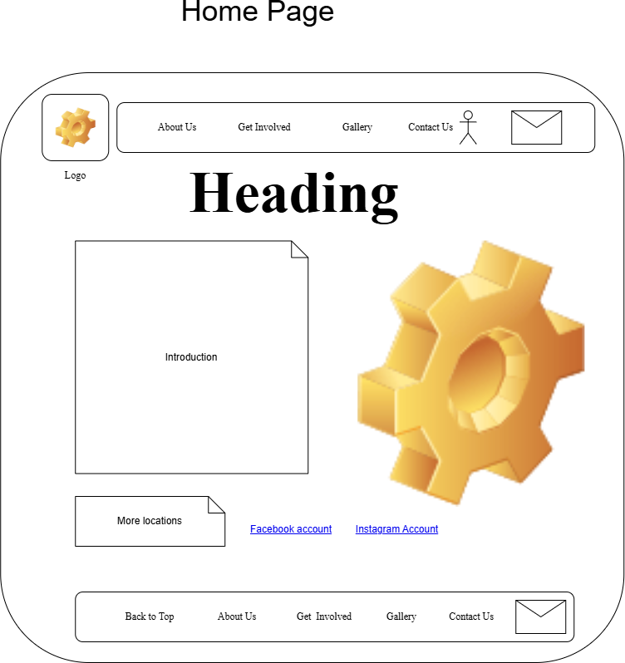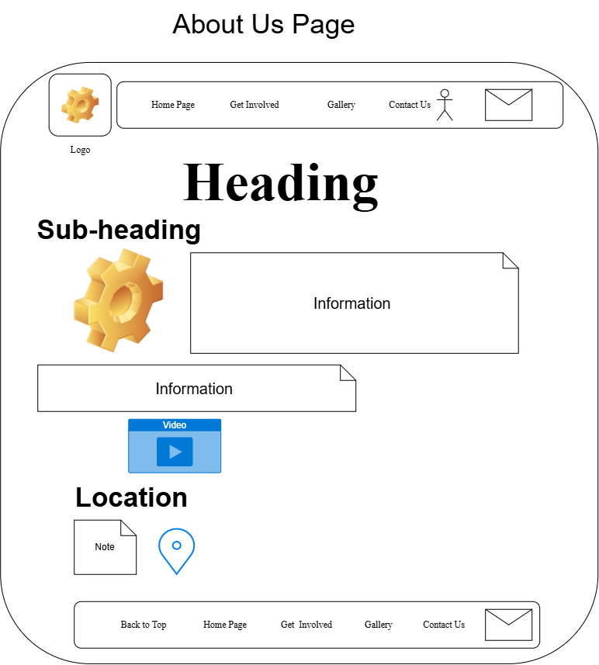

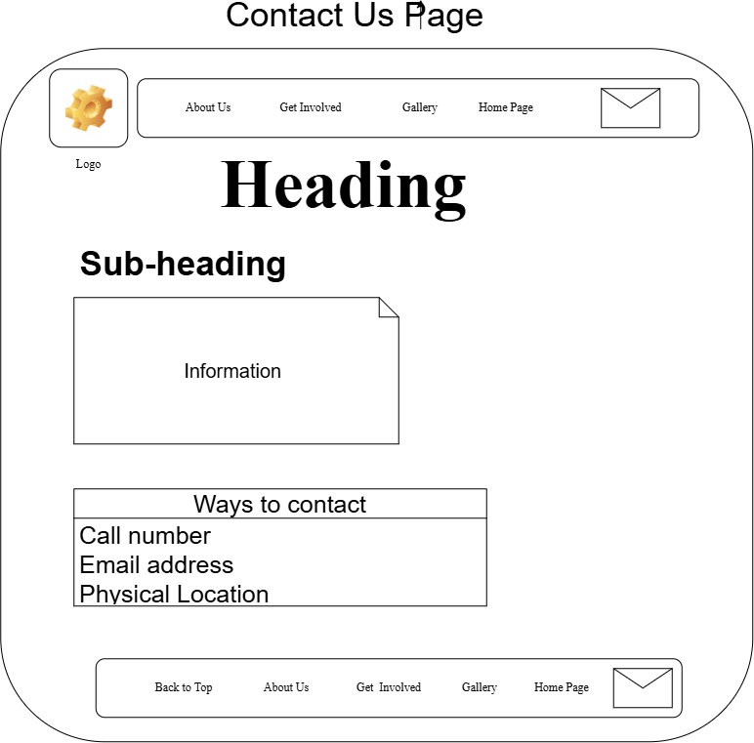
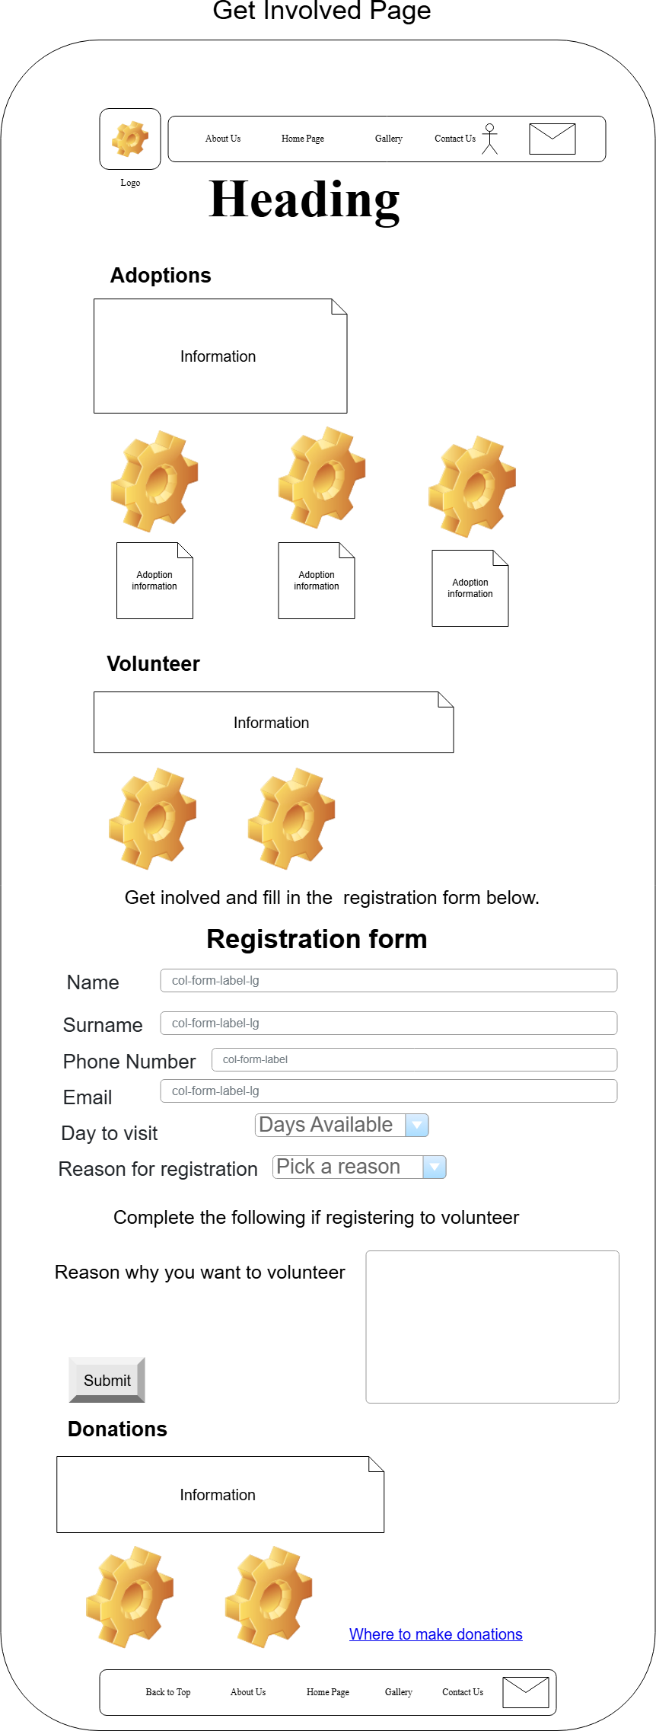
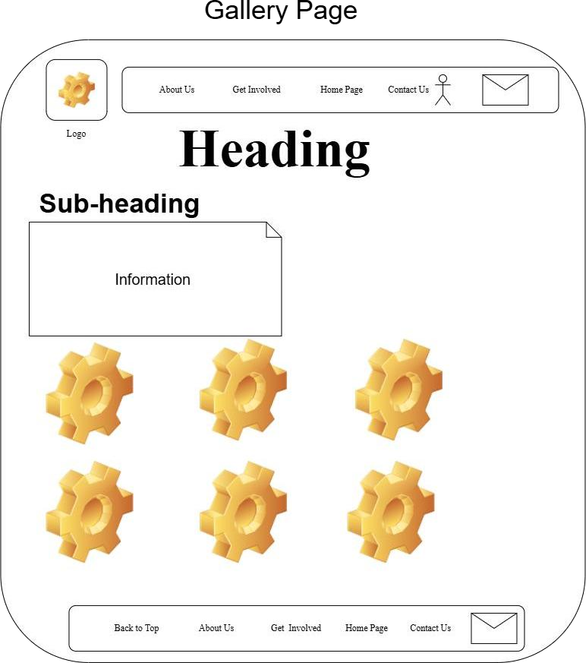

Technical Requirements

Domain name requirements:
  - For the domain name, we will use a unique name for the website address.
  - An Example of the domain name is: pawrus.co.za
  - Thus, the organization will require a registered domain.
  - The domain requires HTTPS/SSL to ensure the public can access the website securely.

Website Hosting Requirements:
  - The website requires a significant amount of storage that allows the organization to consistently post images of their activity.
  - Requires a free SSL certificate.
  - Should allow email support for the organization to receive enquiries from the public.
To ensure the organization remains in control of the website, it should retain ownership of the domain and hosting accounts for the website.

Timeline and Milestones
The website Timeline:
The completion of the website for the organization could take a duration of 8 to 10 weeks.
  - Week 1-2: Researching and planning for websites.
  - Week 3-4: Wireframe website layout and design
  - Week 5-6: Begin coding website interface.
  - Week 7-8: Implement website functionalities.
  - Week 9: Test website features and functionality
  - Week 10: Finalize website with organization before website launch.

The following is a breakdown of the milestones that hinder the progression of the website from being complete early in accordance with the timeline of the website:
  - Planning the website requirements and gathering necessary information for the website.
  - Designing the wireframe
  - Coding the website structure
  - Implementing the backend code for the website functionality
  - Website testing
  - Receiving organization approval of the website before the launch

Budget
Cost of website development:
  - The development of the website will cost the organization an average amount of R7000 to R10000.
  - Registration of the domain is R100-R150 /year.
  - Web hosting costs R100-R300 per month; this covers the costs of website storage and SSL certification.
  - For the maintenance of the website, the organization will pay R700- R1000 per month, which will cover website updates, technical support, and security maintenance.

Thus, the overall estimated costs for the website, including the website development, hosting and maintenance, will be R20 000 to R30 000.

References
  - Afrihost, n.d. Domains. [Online] Available at: https://www.afrihost.com/domains?utm_source
=chatgpt.com [Accessed 9 August 2026].
  - Encrypt, L., n.d. Website encryption. [Online] Available at: https://letsencrypt.org/?utm_source=chatgpt.co m [Accessed 9 August 2026].
  - Maps, G., n.d. Google Maps Platform. [Online] Available at: https://mapsplatform.google.com/?utm_source
=chatgpt.com
[Accessed 10 August 2026].
  - WAI, n.d. Making the web accessible. [Online] Available at: https://www.w3.org/WAI/?utm_source=chatgpt. com
[Accessed 10 August 2026].
  - SA, P. R. U., n.d. Paw R Us SA. [Online]
Available at: https://www.facebook.com/PawsRUS.SA
[Accessed 10 August 2026].
  - SA, P. R. U., n.d. Paw R Us SA. [Online] Available at: https://www.instagram.com/pawsrus_sa/ [Accessed 10 August 2026].

Web Development and Design POE

Part 1: Project Initiation and Planning
Name: Lethabo
Surname: Moganedi
Student Number: ST 10526921 Module: Web Development Module Code: WEDE5021
Lecturer: Mr. L. Matshakatini Submission Date: 14 August 2026

Table of Content



Organization History
  - The Malusi Youth Development Organization was established and founded on the 20th of February 2015 by a group of young people.
  - The organization was created upon the youth recognizing that many young people in many underdeveloped communities were disadvantaged from continuing their education further. And this was the beginning of the organization that made it come into development.
  - The organization initially began as a small tutoring campaign with students volunteering to help children with schoolwork, but this initiative later grew with the support of the community and local businesses, and even the University of Pretoria (UP) assisted in the growth of the organization.

  - Over time MYOD the tutoring campaign transformed into a youth development organization that was dedicated to teaching young people skills with community supported program.

Mission and Vision Statement
Organization Mission:
The Following are the missions that the organization wishes to achieve during its active establishment in the community:
  - To support young people in South Africa, obtain skills to help ensure them employment.
  - Create opportunities for the youth living with disadvantages in their communities.
  - All together the organization aims to help young people who are unfortunate enough to continue or complete school due to financial circumstances and difficulties at home.
  - Organization Vision:
  - The organization visions to create for the youth of South Africa a better and more hopeful future for them to look forward to.

Website Target Audience
The target audience for the Malusi Youth Development Organization are the following people:
  - Disadvantaged young people.
  - High school learners
  - Primary learners
  - Young people interested in developing new skills
  - Youth living around Pretoria.
  - Young people living in under-resourced communities.

Website Goals and Objectives

Website Goals and Objectives:
The website for the organization aims to complete the following tasks for the youth:
  - Update the youth about skill development opportunities.
  - Allow the organization to engage more with the public.
  - Create more opportunities for the organization.
  - Invite more organizations to participate.
  - in the organization’s community investment.

Current website Analysis
Weaknesses:
  - No official hosted website on the internet
  - Little information found when researched.
  - Only one provided contact details for the organization available for the public to use.
  - Provided programs are not posted online.
Strengths:
  - Organization frequently engages with public on Facebook.
  - They have a LinkedIn account link on Facebook.

Improvements:
  - Create an online website for organization.
  - Create web pages to post available programs.
  - Provide more than one contact detail for the public to use.

Website features and functionality
Features on the website:
  - Home Page
  - About Us
  - Contact Us
  - Training programs Available
  - Apply
  - Register Online
  - Gallery

Functionality on the website:
  - Program Registration
  - Enquiries form.
  - Google Maps location

Design and User Experience

Website Typography:
  - Poppins
  - Open Sans
The following features are used to consider User experience:
  - Simple Navigation layout
  - Readable Typography
  - Consistent design throughout the website
  - FAQ section made available to users if they have questions or enquiries about the organization.
  - Back-to-top button for time conservation.

Technical Requirements
Domain name requirements:
  - For the domain name, we will use a unique name for the website address.
  - An Example of the domain name is: pawrus.co.za
  - Thus, the organization will require a registered domain.
  - The domain requires HTTPS/SSL to ensure the public can access the website securely.

Website Hosting Requirements:
  - The website requires a significant amount of storage that allows the organization to consistently post images of their activity.
  - Requires a free SSL certificate.
  - Should allow email support for the organization to receive enquiries from the public.
To ensure the organization remains in control of the website, it should retain ownership of the domain and hosting accounts for the website.

Timeline and Milestones
The website Timeline:
The completion of the website for the organization could take a duration of 8 to 10 weeks.
  - Week 1-2: Researching and planning for websites.
  - Week 3-4: Wireframe website layout and design
  - Week 5-6: Begin coding website interface.
  - Week 7-8: Implement website functionalities.
  - Week 9: Test website features and functionality
  - Week 10: Finalize website with organization before website launch.

The following is a breakdown of the milestones that hinder the progression of the website from being complete early in accordance with the timeline of the website:
  - Planning the website requirements and gathering necessary information for the website.
  - Designing the wireframe
  - Coding the website structure
  - Implementing the backend code for the website functionality
  - Website testing
  - Receiving organization approval of the website before the launch

Budget
Cost of website development:
  - The development of the website will cost the organization an average amount of R7000 to R10000.
  - Registration of the domain is R100-R150 /year.
  - Web hosting costs R100-R300 per month; this covers the costs of website storage and SSL certification.
  - For the maintenance of the website, the organization will pay R700- R1000 per month, which will cover website updates, technical support, and security maintenance.

Thus, the overall estimated costs for the website, including the website development, hosting and maintenance, will be R20 000 to R30 000.

References
  - Afrihost, n.d. Domains. [Online] Available at: https://www.afrihost.com/domains?utm_source
=chatgpt.com [Accessed 9 August 2026].
  - Encrypt, L., n.d. Website encryption. [Online] Available at: https://letsencrypt.org/?utm_source=chatgpt.co m [Accessed 9 August 2026].
  - Maps, G., n.d. Google Maps Platform. [Online] Available at: https://mapsplatform.google.com/?utm_source
=chatgpt.com [Accessed 10 August 2026].

- OpenAI (2026) ChatGPT [Large language model]. Available at: ChatGPT (Accessed: 15 August 2026).
  - WAI, n.d. Making the web accessible. [Online] Available at: https://www.w3.org/WAI/?utm_source=chatgpt. Com [Accessed 10 August 2026].

Global, F., n.d. Malusi Youth Development Organization. [Online] Available at: https://www.findglocal.com/ZA/Pretoria/930541583695718/Malusi-Youth-Development-OrganisationMYDO [Accessed 12 August 2026].

Content Research and sourcing
Home Page:
Paw R Us SA is a pet welfare organisation that was founded in 2018 by a group of pet owners.
Our organisation is an animal-focused organisation that mainly operates its activities online through a Facebook account.
The presence of Paw R Us SAs can be felt online through many social media platforms. Our engagement online is used for two most important things including the following:
- Firstly, to engage with our pet lovers
- Secondly, to seek out for donors and sponsors who can help support fight against the financial constraints of the animals that prevent them from receiving care and a good upbringing.
- About Us Page:
- Meet the Paw R Us SA Team
- This team is the backbone of the organization and the individuals who have allowed the journey of the organization to remain active and dedicated to its services in the community
- Every team member's work or role in the organization is as significant as any other individual's role because each member's contribution is very crucial for the growth of the organization and its success.

Paw R Us SA Successful stories
Paw R Us SA was founded to assist animals find their "forever homes" hence that has always been a major goal for the organization, to help animals that were once abandoned find a new place to call home.
Over the past years we have successfully been able to do exactly that for our lovely furry family and we promise to continue doing so for the many more year the organization has. Finding homes for our furry family has never been something easy but each time we are able to give a dog a chance at a second in life, to start afresh and the opportunity to feel loved again we feel at ease and content that all our hard work has not gone to waste because Finally our furry family has found a new family to call its own.!

Get Involved Page:
Adoption
One of Paw R Us SA's core missions is to provide a safe and loving environment for animals in need. The organisation believes that every animal deserves a place to call home, and we are committed to making that a reality for as many animals as possible.
Though some dogs have experienced neglect, abandonment and terribles past it does not mean their past should define their future. Because through patience, love an immense kindness the lives of these dogs could be changed for the better, granting them the opportunity to be loved and given a second chance in life.
Volunteering:
There are various ways in becoming a member of the Paw family. But one of the most common ways many of the public have become part of us is through volunteering.
For the past years the organisation has relied heavily on the kindness and dedication of many volunteers who have given their time to assist grow and support the animals at Paw R Us SA. And it because of our volunteers that today the organisation remains to continue its job to rescue and care for animals in need of our services.

Donations:
Another one of Paw R Us SA's reasons why we have come so far with our work is because of the wonderful donation made by our blessed donors and sponsors that have helped create a meaningful difference in the lives of our Paw animals.
Every Donation made by has made a significant impact on our ability to care for these wonderful animals and has been very reassuring for the organizations that hope still remains for our journey to continue rescuing animals

Gallery Page:
Come meet Paw R Us SA's furry family!
The following are images of our amazing dogs that have been a huge part of Paw R Us SAs journey and lives.
These animals are not just pets but are the beloved members and family of our organisation, the sole reason why we have been thriving for the past years.
They are also the motivation behind the organisation's work. So please do take your time and show appreciation for our furry friends.

Contact Page:
How to contact Paw R Us SA
To contact Paw R Us SA you can the following to reach our organisation for any enquiries you may possibly have:
- Call : 083 518 0447
- Email:
- woof@pawsrus.co.za

Website Structure and planning
The following image is an example of how the website’s navigation system works in the website. In other words, it is an illustration presenting the sitemap of the website:
Website Sitemap:


